**Object Oriented System Analysis and Design (OOSA&D)**

**Course Code: CST 2234**

**Lab # 1**

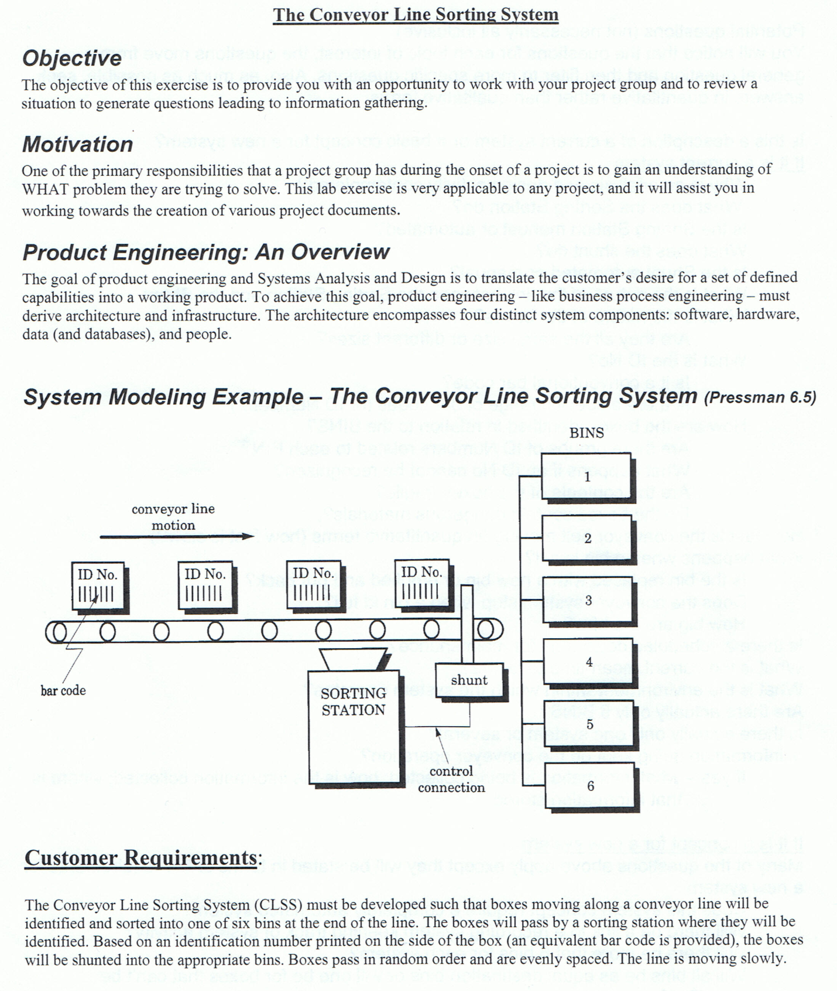

**Guidelines:**

**You must be focusing on the following aspects while doing the Analysis on this scenario;**

1. Focus on the Hardware parts of the system i.e. belt, bins, sorting stations, shunting, sensor, boxes and develop the questions. Your questions may highlight different issues/problems faced by the operators.

2. Develop your questions based on issues regarding i.e. boxes, bins and control station. Identify the maximum possible issues being faced or may be faced by the employees.

3. Do not forget to analyze software/digital aspect of the Conveyor Line Sorting System in the form of Sorting Station. You may also highlight possible failures by sensor based sorting station. Develop your questions on the basis on these issues/problems.

4. If system does not exist, then what kind of questions you are going to ask from the client.